**Shahjalal University of Science and Technology, Sylhet**

**Course number: CHE471**

**Course name: Research Project**

**A convenient method for synthesizing substituted olefins, including 2-(4- methyl benzylidene) malononitrile, 2-(4-flurobenzylidene) malononitrile, 2-(4- nitro benzylidene) malononitrile, and 2-(4-chlorobenzylidene) malononitrile using microwave irradiation**

**Submitted by:** Mohammad Masud Hossen Shipon

**Registration no:** 2019131107

**Session:** 2019-20

**4th year 2nd semester**

**Abstract:**

A convenient method for synthesizing substituted olefins, including 2-(4- methyl benzylidene) malononitrile, 2-(4-flurobenzylidene) malononitrile, 2-(4- nitro benzylidene) malononitrile, and 2-(4-chlorobenzylidene) malononitrile using microwave irradiation. Urea is used as a catalyst for the α, β-unsaturated Knoevenagel condensation of various substituted aromatic aldehydes and active methylene compounds such as malononitrile, resulting in high yields and less reaction time, ensuring a cost-effective and environmentally friendly process. This approach can also be applied to the synthesis of various compounds derived from aromatic aldehydes.

**Keywords:** Microwave-Assisted Synthesis, Active Methylene Compounds, malononitrile, Substituted Aromatic Aldehydes, Urea Catalyst, Green Chemistry, Microwave Technology

Index

1. Introduction 3
2. Microwave Technology 4
   1. Heating Mechanism of Microwave Synthesis 5
   2. Difference Between Conventional Heating and Microwave Heating 6
3. Objectives 7
4. Experimental Section 8
   1. General 8
   2. Chemicals 8
   3. Melting point measurement 8
   4. Reaction Monitoring 8
   5. Thin Layer Chromatography 9
   6. Column Chromatography 10
   7. Recrystallization 11
   8. Spectroscopic measurement 11
5. Methodology 11
6. Experiments 13
   1. Reaction of 4-methylbenzaldehyde with malononitrile 13
   2. Reaction of 4-flurobenzaldehyde with malononitrile 14
   3. Reaction of 4-nitrobenzaldehyde with malononitrile 15
   4. Reaction of 4-chlorobenzaldehyde with malononitrile 16
7. Comparison between thermal and microwave reactions 17
8. Results and Discussion 18
   1. Synthesis of 2-(4-methylbenzylidene) malononitrile 18
   2. Synthesis of 2-(4-flurobenzylidene) malononitrile 20
   3. Synthesis of 2-(4-nitrobenzylidene) malononitrile 22
   4. Synthesis of 2-(4-chlorobenzylidene) malononitrile 25
9. Overview of the Synthesis 27
10. Conclusion 28
11. Reference 29

# Introduction

The Knoevenagel condensation reaction plays a crucial role in synthesizing fine chemicals [1] and biologically viable compounds [2] by producing carbon-carbon double-bonded compounds from aldehyde and active methylene compounds. Generally, this reaction is a nucleophilic addition of a carbonyl group to an active methylene compound [3]. After the nucleophilic addition, the intermediate undergoes a dehydration or condensation reaction where a molecule of water is eliminated, leading to the formation of a double bond between the α and β carbons. This results in the synthesis of an α,β-unsaturated carbonyl compound. The carbonyl group used in this reaction is either an aldehyde or ketone. During this reaction, the active hydrogen of reactive methylene is deprotonated by a strong base, that is used as a catalyst, creating an enolate ion. This enolate ion then reacts with an electrophile, often an aldehyde or ketone, to form a new carbon-carbon bond, leading to the synthesis of α,β-unsaturated carbonyl compounds.





Scheme 1: Knoevenagel condensation reaction

In Z-CH2-Z, Z indicates an electron-withdrawing functional group such as -CN(cyano), and NO2 that are able enough to facilitate deprotonation of the α-hydrogens, forming an enolate ion under mild base conditions.



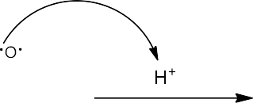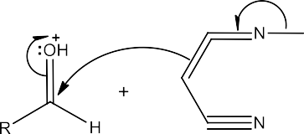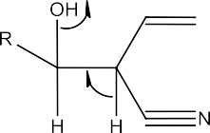

Scheme 2: Knoevenagel reaction mechanism

Self-condensation of the aldehyde or ketone is also possible by using a strong base. Yang Y [4] carried out this reaction using strong bases such as sodium hydroxide or sodium ethoxide in an organic solvent.

However, the usage of strong bases and organic solvents is not eco-friendly. There are alternative methods to carry out the reaction in solvent-free conditions. Rao [5] and Cruz [6] used ZnCl2 and silica gel as a catalyst, respectively, to perform the Knoevenagel condensation of aldehyde and malononitrile in a dry medium. Since these catalysts are expensive, using urea as a catalyst is more cost-effective and environmentally friendly. Additionally, this microwave-synthesized method is efficient, requiring a short reaction time, and providing a higher percentage of yield than the conventional heating system. Ren [7], and Kaupp [8] described the conventional heating system that significantly requires a long reaction time to form the olefins.

# Microwave Technology

Microwave technology has become increasingly prevalent in a variety of scientific and industrial applications. This technology involves the generation of electromagnetic waves within the microwave frequency range, which interact with polar molecules to induce rotation and generate kinetic energy. This rotational movement results in intermolecular friction [9], leading to heat generation. Additionally, when an electric field is present, molecules with a permanent dipole moment align themselves with this field [10]. This technology is also characterized by dielectric polarization, which causes electrical insulator molecules to rapidly adjust their orientation in response to the alternating electric field. This efficient energy transfer method ensures precise and rapid heating, making it highly targeted and reducing energy loss in the process.

Microwave technology's heating mechanism sets it apart from other forms of electromagnetic radiation, such as X-rays and gamma rays, which operate on different principles and are primarily ionizing in nature. One of the elementary benefits of microwave technology is its ability to deliver microwave energy directly to the substance being heated, ensuring an efficient process with minimal energy waste. This molecular heating mechanism is more precise and faster than conventional heating methods, which can be slower and less accurate.

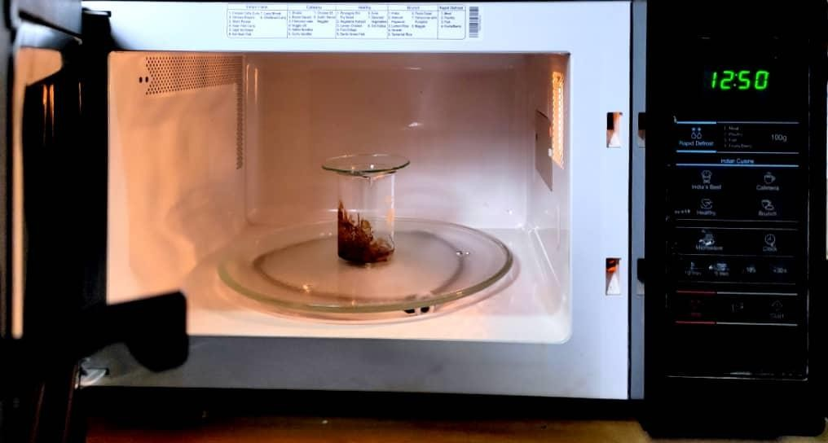

Figure 1: Domestic Microwave Oven

Microwave technology is particularly significant in chemical synthesis, offering numerous benefits. Microwave synthesis is known for its ability to facilitate rapid and controlled reactions, resulting in reduced energy consumption and improved yields. This approach aligns with green chemistry practices, contributing to more environmentally friendly and efficient chemical processes.

# Heating Mechanism of Microwave Synthesis

Microwave synthesis relies on two essential processes for heating:

1. **Dipolar Polarization:** Dipoles, which are compounds with partially positive and negative charges, align themselves with the oscillating electric field. Such alignment results in rapid molecular rotation which generates heat energy from friction.
2. **Ionic Conduction:** Charged particles such as ions dissolve and oscillate under microwave radiation. These oscillations cause collisions with nearby molecules or atoms, which in turn generate heat energy.

Both processes convert microwave energy into heat, allowing for swift and effective heating in chemical reactions.

# Difference Between Conventional Heating and Microwave Heating

**Table 1:** Difference between conventional and microwave heating systems.

|  |  |  |
| --- | --- | --- |
| **Key points** | **Conventional heating** | **Microwave heating** |
| **Heating**  **mechanism** | Relies on heat transferring from a  heat source to the material | Converts electromagnetic radiation to  heat energy |
| **Uniformity of heating** | Heats from the outside, often  resulting in uneven heating and temperature gradients | Heats volumetrically, leading to more  uniform and rapid heating throughout the material |
| **Heating speed** | Slower as heat is transferred  gradually through conduction | Faster as heat is directly provided to  the materials |
| **Energy**  **efficiency** | Leads to energy loss due to slowness  and uneven heating | Uses maximum energy because of  direct heating |
| **Applications** | Common in traditional cooking and heating processes. | Widely used in chemistry, material  processing, and some food preparation methods. |

# Objectives

The Knoevenagel condensation reaction is a widely used method for synthesizing substituted olefin, often utilizing the microwave technique. The features of this method are its short reaction time, solvent-free conditions, and the use of a cost-effective catalyst. The objectives of this project include:

1. Synthesis of various C=C bonded organic compounds by Knovenagel reaction from various aromatic aldehydes and active methylene compounds using urea as a catalyst under microwave irradiation.
2. Characterization of the synthesized products by melting point and spectroscopic methods.

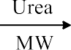



|  |  |
| --- | --- |
| 1a, Ar = 4-CH3C6H4  1b, Ar = 4-FC6H4  1c, Ar = 4-NO2C6H4  1d, Ar = 4-ClC6H4 | 3a, Ar = 4-CH3C6H4  3b, Ar = 4-FC6H4  3c, Ar = 4-NO2C6H4  3d, Ar = 4-ClC6H4 |

Scheme 3

# Experimental Section

# General

The reactions were conducted using standard conditions and high-quality chemicals sourced from reliable commercial suppliers, including ALDRICH and MERCK, without any additional purification. Analytical Thin-Layer Chromatography (TLC) was performed on pre-coated alumina sheets, with product visualization achieved using UV light. The chemical reactions were carried out using a Samsung domestic microwave oven (model MW76ND).

# Chemicals

The chemicals employed in this experiment are malononitrile as the active methylene source, 4- methyl benzaldehyde (1a), 4-fluorobenzaldehyde (1b), 4-nitrobenzaldehyde (1c), and 4- chlorobenzaldehyde (1d) as the substituted aldehydes and urea as a catalyst.

# Melting point measurement

The melting point was measured using the Gallen Kamp melting point apparatus with great precision and care.

# Reaction Monitoring

Reactions were monitored using thin-layer chromatography with a mobile phase consisting of n- hexane and ethyl acetate in various ratios. For this, a small amount of the reaction mixture was taken in a small vial and dissolved in ethyl acetate. In the same way, more vials were made for reactants and catalysts. Then reaction mixture, reactants and catalysts were spotted on the TLC plate and kept that plate in a mobile phase having n-hexane and ethyl acetate in various ratios. As the compounds are UV active, they were detected under UV lamps by their different Rf (retardation factor) values. Through this process, we ensured the completion of a reaction.

# Thin Layer Chromatography

Thin layer chromatography (TLC) is a chromatographic method employed for both qualitative and quantitative analysis. It is particularly useful for preliminary screening and identifying compounds within a mixture.

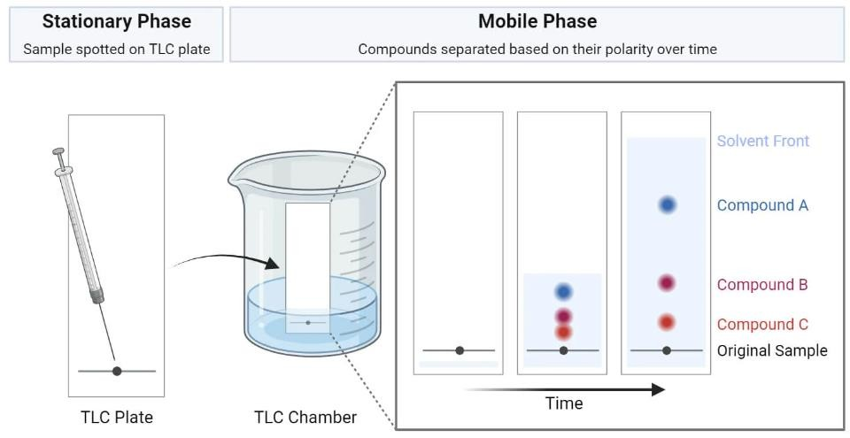

Figure 2: Thin Layer Chromatography

TLC utilizes a stationary phase in the form of a thin layer of adsorbent material, such as alumina or silica, which is supported on a plate or strip. A small sample of the mixture is spotted in the stationary phase, and the chromatogram is developed by exposing the plate to a solvent, allowing the solvent to move through the stationary phase.

During this development process, the compounds in the sample migrate up the plate at varying rates due to their different interactions with the stationary and mobile phases. After development, the individual compounds become visible as spots on the TLC plate. These spots can be further analyzed and identified based on their characteristic Rf (retardation factor) values, which describe the relative movement of each compound compared to the solvent. TLC is a valuable and cost- effective tool for separating and characterizing compounds in complex mixtures.

# Column Chromatography

Column chromatography is a highly effective technique for separating and purifying individual components from a mixture through their varying affinities for a stationary and mobile phase. The process involves loading a mixture onto a vertical glass column filled with a stationary phase such as silica gel or alumina and eluting it with a solvent (mobile phase). This causes the components to travel through the stationary phase at different rates, ultimately leading to their separation and elution from the column at different times. By isolating individual substances from the original mixture in this way, column chromatography allows for precise purification and collection of the desired component.

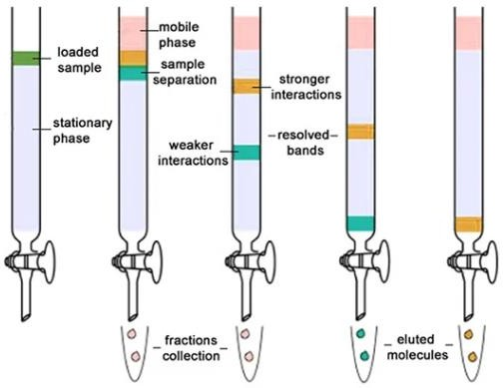

Figure 3: Column Chromatography

# Recrystallization

Recrystallization is a reliable and straightforward method for purifying solid compounds. To dissolve the compound, a hot solvent such as ethyl acetate was used. This is because most solid organic compounds have higher solubility at elevated temperatures due to increased kinetic energy, allowing them to disperse evenly in the solution. A small amount of n-hexane was also added to reduce the solubility of the dissolved compound. This induces cloudiness in the solution because it has a lower boiling point and is less polar than the primary solvent (ethyl acetate in this case). As the solution cools, the molecules of the less polar n-hexane contribute to reducing the overall polarity of the solvent mixture. Moreover, during colling, the molecules in the solution lose kinetic energy, making them less likely to stay in the solution and more likely to form a solid crystal. Over time, crystals grew by selecting only the right molecules that fit perfectly into their structure while leaving behind the impurities in the liquid. This results in a highly pure final product collected through filtration.

# Spectroscopic measurement

* + 1. **IR Spectra**

The IR spectra was measured using a Shimadzu FTIR- spectrometer in the Department of Chemistry, Shahjalal University of Science and Technology, Sylhet.

# NMR Spectra

Due to the time constraints of this project, obtaining NMR spectra for the compounds was not possible. So, NMR spectral data will be taken later.

# Methodology

In a 50 mL Pyrex glass beaker, a mixture was prepared by combining 2 mmol of an aromatic aldehyde with 2 mmol of an active methylene compound (e.g., malononitrile). A catalytic amount of urea (10 mol%, equivalent to 0.2 mmol) was added to the mixture. The mixture was thoroughly mixed using a glass rod to form a paste. In cases where the compounds were in solid form, a small amount of organic solvent (ethyl acetate) was used to facilitate the formation of this paste. Then the mixture was irradiated under microwave at varying power levels, ranging from 180W to 800W, for a duration of 1 to 5 minutes. The progress of the chemical reaction was monitored using thin-

layer chromatography (TLC) with a mobile phase consisting of n-hexane and ethyl acetate in various ratios.

Upon achieving complete conversion of the reactants and allowing the reaction mixture to cool, the solid residue was treated with water to remove the urea catalyst. For this, the sample was mixed with a small amount (2 ml) of water and EtOAc in a separating funnel. After the separation of the organic and aqueous layers, the organic layer was preserved. Because the reaction mixture is soluble in organic solvent. To eliminate any remaining water or moisture from organic layer, a small amount of anhydrous MgSO4 was added. The MgSO4 was removed by filtration.

Then the solution was heated in a controlled manner to initiate the recrystallization process, with the addition of a modest quantity of n-hexane. The solution was cooled slowly to facilitate the formation of high-purity crystals. The purified product was collected through filtration, and its melting point was measured. Subsequently, the product was brought comprehensive characterization through IR spectroscopic analysis to affirm its structural composition.

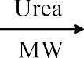



|  |  |
| --- | --- |
| 1a, Ar = 4-CH3C6H4  1b, Ar = 4-FC6H4  1c, Ar = 4-NO2C6H4  1d, Ar = 4-ClC6H4 | 3a, Ar = 4-CH3C6H4  3b, Ar = 4-FC6H4  3c, Ar = 4-NO2C6H4  3d, Ar = 4-ClC6H4 |

Scheme 4

# Experiments

# Reaction of 4-methylbenzaldehyde with malononitrile

In a 50 mL Pyrex glass beaker, 4-methylbenzaldehyde (1a) (0.2365 mL, 2 mmol), malononitrile

(2) (0.1345 g), and urea (0.0013 g, 10 mol %, 0.2 mmol) were taken and mixed thoroughly with a glass rod. Then the mixture was irradiated under microwave at 300 watts for 1.5 minutes. The progress of the mixture was followed by TLC with a mobile phase consisting of n-hexane and ethyl acetate in various ratios. After complete reaction and cooling, the mixture was washed with water to remove urea. Then the reaction mixture was recrystallized to get the pure product 2-(4- methyl benzylidene) malononitrile (3a).

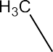





Scheme 5: Reaction of 4-methylbenzaldehyde (1a) with malononitrile (2)

Characterization of the compound:

Physical state : white solid

Yield : 89 %

Melting point (℃) : 133-135℃ (lit.134℃ [7])

Rf value : 0.51 (n-hexane: ethyl acetate = 3 : 1)

IR (υmax (cm-1)) : 3035 (sp2 C-H), 2222 (C≡N) and 1589 (C=C) cm-1

# Reaction of 4-flurobenzaldehyde with malononitrile

In a 50 mL Pyrex glass beaker,4-flurobenzaldehyde (1b) (0.2181 mL, 2 mmol), malononitrile (2) (0.1346 g), and urea (0.0013 g, 10 mol %, 0.2 mmol) were taken and mixed thoroughly by a glass rod. Then the mixture was irradiated under microwave at 600 watts for 4.5 minutes. The progress of the mixture was followed by TLC with a mobile phase consisting of n-hexane and ethyl acetate in various ratios. After complete reaction and cooling, the mixture was washed with water to remove urea. Then the reaction mixture was recrystallized to get the pure product 2-(4- flurobenzylidene) malononitrile (3b).







Scheme 6: Reaction of 4-flurobenzaldehyde (1b) with malononitrile (2)

Characterization of the compound:

Physical state : light brown solid

Yield : 83 %

Melting point (℃) : 123-125℃ (lit.124-125℃ [11])

Rf value : 0.71 (n-hexane: ethyl acetate = 3 : 1)

IR (υmax (cm-1)) : 3043 (sp2 C-H), 2229 (C≡N) and 1593 (C=C) cm-1

# Reaction of 4-nitrobenzaldehyde with malononitrile

In a 50 mL Pyrex glass beaker, 4-nitrobenzaldehyde (1c) (0.2971 g, 2 mmol), malononitrile (2) (0.1352 g), and urea (0.0013 g, 10 mol %, 0.2 mmol) were taken and mixed thoroughly by a glass rod. Then the mixture was irradiated under microwave at 600 watts for 3.5 minutes. The progress of the mixture was followed by TLC with a mobile phase consisting of n-hexane and ethyl acetate in various ratios. After complete reaction and cooling, the reaction mixture was washed with water to remove urea. Then the reaction mixture was recrystallized to get the pure product 2-(4- nitrobenzylidene) malononitrile (3c).

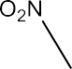





Scheme 7: Reaction of 4-nitrobenzaldehyde (1c) with malononitrile (2)

Characterization of the compound:

Physical state : yellowish-white solid Yield : 87 %

Melting point (℃) : 161-163 ℃ (lit.160℃ [12])

Rf value : 0.36 (n-hexane: ethyl acetate = 4 : 1)

IR (υmax (cm-1 )) : 3039 (sp2 C-H), 2233 (C≡N), 1604 (C=C), 1523 (N=O), 1346 (N-O) cm-1

# Reaction of 4-chlorobenzaldehyde with malononitrile

In a 50 mL Pyrex glass beaker, 4-chlorobenzaldehyde (1d) (0.2739 g, 2 mmol), malononitrile (2) (0.1343 g), and urea (0.0013 g, 10 mol %, 0.2 mmol) were taken and mixed thoroughly with a glass rod. Then the mixture was taken under microwave irradiation at 800 watts for 4.5 minutes. The progress of the reaction was followed by TLC with a mobile phase consisting of n-hexane and ethyl acetate in various ratios. After complete reaction and cooling, the mixture was washed with water to remove urea. Then the reaction mixture was recrystallized to get the pure product 2-(4- chlorobenzyl Dene)malononitrile (3d).







Scheme 8: Reaction of 4-chlorobenzaldehyde (1d) with malononitrile (2)

Characterization of the compound:

Physical state : white solid

Yield : 90 %

Melting point (℃) : 161-163 ℃ (lit. 165℃ [12])

Rf value : 0.69 (n-hexane: ethyl acetate = 3: 1)

IR (υmax (cm-1)) : 3035 (sp2 C-H), 2225 (C≡N) and 1581 (C=C) cm-1

# Comparison between thermal and microwave reactions

The reaction of various aromatic aldehyde and active methylene compounds such as malononitrile was conducted thermally by Ren [7] and Kaupp [8] within 150-185℃ and continuous stirring for 1-2 hours. The comparison between the conditions of thermal and microwave reactions is shown in Table 2.

**Table 2:** Comparison of the same reaction in thermal condition and microwave condition.

|  |  |  |  |  |  |
| --- | --- | --- | --- | --- | --- |
| **Comp. No.** | **Ar** | **Thermal (time/hour)** | **Thermal (yield %)** | **Microwave (time/min)** | **Microwave (yield %)** |
| **3a** | 4-CH3C6H4 | 2 [7] | 96 | 1.5 | 89 |
| **3c** | 4-NO2C6H4 | 1 [8] | 96 | 3.5 | 87 |
| **3d** | 4-ClC6H4 | 1 [8] | 91 | 4.5 | 91 |

# Results and Discussion

# Synthesis of 2-(4-methylbenzylidene) malononitrile

The compound 2-(4-methylbenzylidene) malononitrile (3a) was synthesized by the reaction of 4- methyl benzaldehyde (1a) and malononitrile (2) in the presence of a catalytic amount of urea under microwave irradiation for 1.5 min at 300 W. The product is white solid having melting point 133- 135 ℃ and the percentage of yield is 89%.

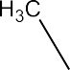





Scheme 9: Synthesis of 2-(4-methylbenzylidene) malononitrile (3a)

## IR spectral analysis:

The IR spectrum of compound 3a, 2-(4- methyl benzylidene)malononitrile, displays an absorption frequency at 3035 cm-1, signifying the existence of aromatic rings in the molecule through the sp2 C-H stretching. The peak at 2360 cm-1 frequency is associated with the cyano group's (C≡N) asymmetric stretching, confirming the presence of a nitrile functional group. Another peak at 2222 cm-1 frequency is related to the nitrile group (C≡N) stretching vibration, reinforcing the identification of the nitrile group in the molecule. The absorption band at 1589 cm-1 frequency indicates C=C stretching vibration, which is conjugated with the aromatic C=C system, consistent with the compound's aromatic structure.



|  |  |  |
| --- | --- | --- |
| sp2 C-H | C≡N | C=C |
| 3035 cm-1 | 2222 cm-1 | 1589 cm-1 |

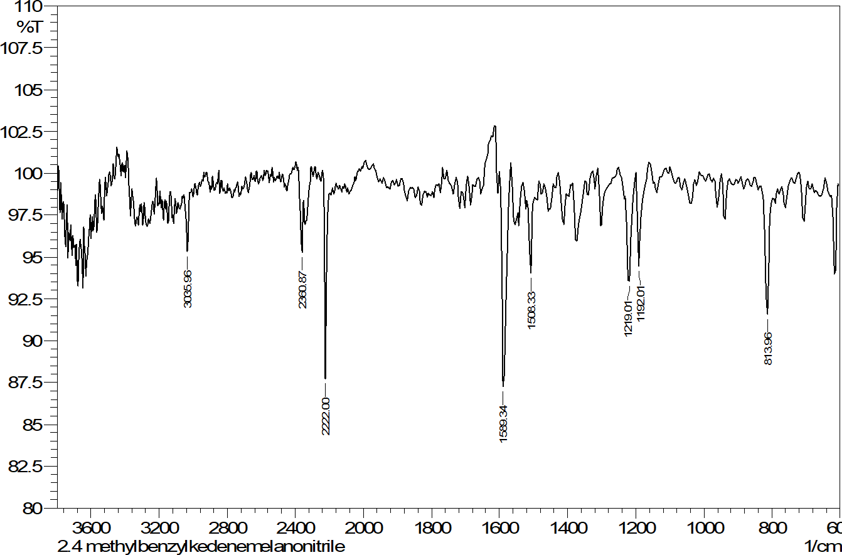

C=C

C≡N

sp2 C-H

Figure 4: FTIR spectrum of 2-(4-methylbenzylidene) malononitrile (3a)

# Synthesis of 2-(4-flurobenzylidene) malononitrile

The compound 2-(4-flurobenzylidene) malononitrile (3b) was synthesized by the reaction of 4- Fluro benzaldehyde (1b) and malononitrile (2) in the presence of the catalytic amount of urea under microwave irradiation for 4.5 min at 600 W. The product is a light brown solid having a melting point of 123-125 ℃ and the percent of yield is 83%.







Scheme 10: Synthesis of 2-(4-flurobenzylidene) malononitrile (3b)

## IR spectral analysis:

The compound 2-(4-flurobenzylidene) malononitrile (3b) shows absorption frequency at 3043 cm-1 corresponding to the aromatic sp2 C-H stretching, indicating the presence of an aromatic ring in the molecule. The absorption band at 2229 cm-1 frequency is associated with the C≡N stretching vibration, confirming the presence of a nitrile group in the compound. The peak at 1593 cm-1 frequency is indicative of C=C stretching vibration, likely conjugated with the aromatic C=C system. The peaks at 1658, 1508 cm-1 align with the presence of an aromatic system. These suggest the presence of an aromatic ring in the



molecule. 2935 cm-1 peak is related to aliphatic C-H stretching, suggesting the presence of aliphatic groups in the compound.

|  |  |  |
| --- | --- | --- |
| sp2 C-H | C≡N | C=C |
| 3043 cm-1 | 2229 cm-1 | 1593 cm-1 |

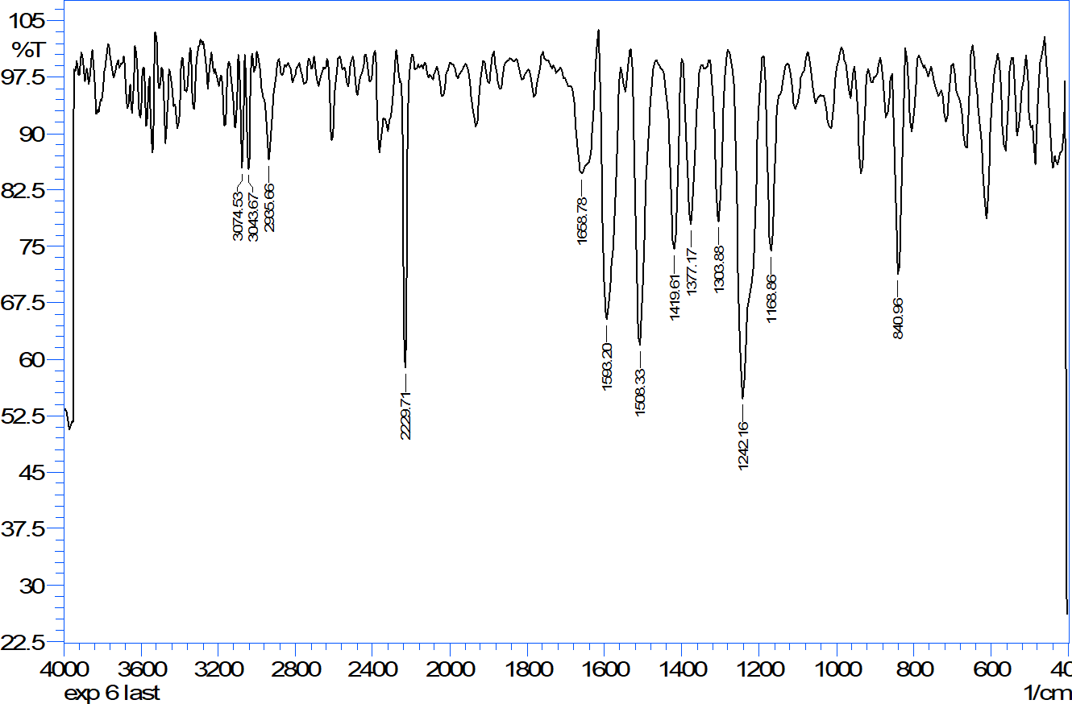

C≡N

C=C

sp2 C-H

Figure 5: FTIR spectrum of 2-(4-flurobenzylidene) malononitrile (3b)

# Synthesis of 2-(4-nitrobenzylidene) malononitrile

The compound 2-(4-nitrobenzylidene) malononitrile (3c) was synthesized by the reaction of 4- nitro benzaldehyde (1c) and malononitrile (2) in the presence of the catalytic amount of urea under microwave irradiation for 3.5 min at 600 W. The product is a yellowish-white solid having a melting point of 161-163 ℃ and the percentage of yield is 87%.

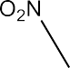





Scheme 11: Synthesis of 2-(4-nitrobenzylidene) malononitrile (3c)

## IR spectral analysis:

The compound 2-(4-nitrobenzylidene) malononitrile (3c) exhibits an absorption frequency at 3039 cm-1 for aromatic sp2 C-H stretching, indicating the presence of an aromatic ring. The 2233 cm-1 absorption band is associated with C≡N stretching, which confirms the existence of a nitrile group in the compound. The absorption at 1604 cm-1 frequency suggests C=C stretching vibration, which is likely conjugated with the aromatic C=C system, thus supporting the presence of an aromatic ring. The peaks at 1523 cm-1 and 1346 cm-1 are attributed to the N=O and N-O stretching vibrations, subsequently, which confirm the existence of nitro groups in the compound.

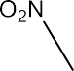

|  |  |  |  |  |
| --- | --- | --- | --- | --- |
| sp2 C-H | C≡N | C=C | N=O | N-O |
| 3039 cm-1 | 2233 cm-1 | 1604 cm-1 | 1523 cm-1 | 1346 cm-1 |

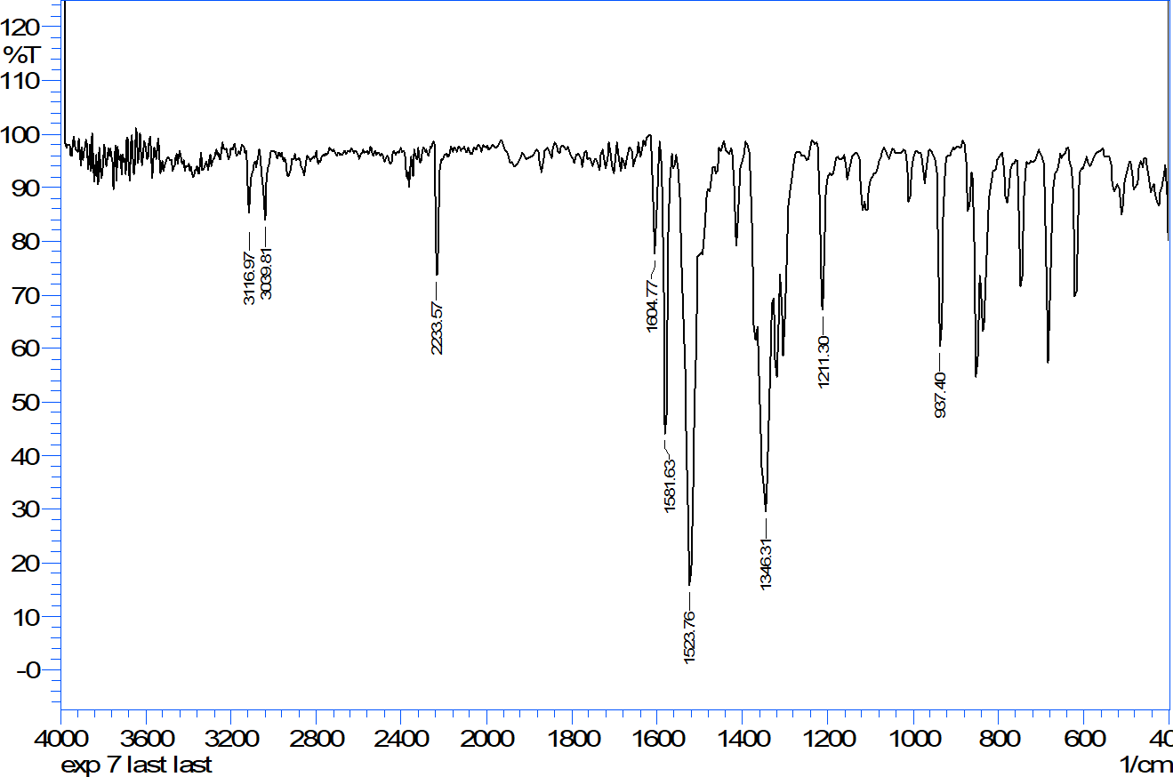

N=O

N-O

C≡N

C=C

sp2 C-H

Figure 6: FTIR spectrum of 2-(4-nitrobenzylidene) malononitrile (3c)

# Synthesis of 2-(4-chlorobenzylidene) malononitrile

The compound 2-(4-chlorobenzylidene) malononitrile (3d) was synthesized by the reaction of 4- chlorobenzaldehyde (1d) and malononitrile (2) in the presence of the catalytic amount of urea under microwave irradiation for 4.5 min at 800 W. The product is a yellowish-white solid having a melting point of 161-163 ℃ and the percentage of yield is 90%.







Scheme 12: Synthesis of 2-(4-chlorobenzylidene) malononitrile (3d)

## IR spectral analysis:

The compound 2-(4-chlorobenzylidene) malononitrile (3d) displays an absorption frequency at 3035 cm-1 for aromatic sp2 C-H stretching, indicating the existence of an aromatic ring. The absorption band at 2225 cm-1 corresponds to C≡N stretching, which confirms the existence of a nitrile group in the compound. The absorption at 1581 cm-1 frequency suggests C=C stretching vibration, likely conjugated with the aromatic C=C system, thereby supporting the existence of an aromatic ring. The peaks at 1489 cm-1 and 1411 cm-1 relate to a vibrational mode connected to the chloro- substituted aromatic ring.



|  |  |  |
| --- | --- | --- |
| sp2 C-H | C≡N | C=C |
| 3035 cm-1 | 2225cm-1 | 1581 cm-1 |

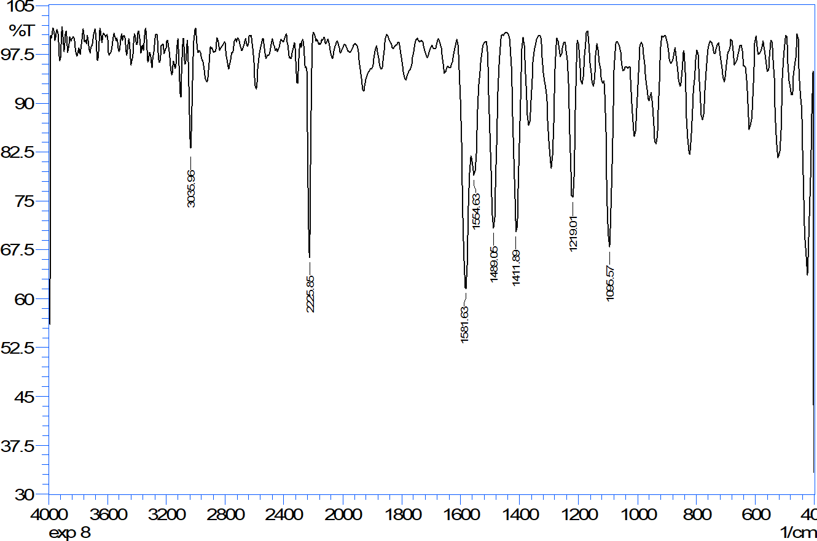

C=C

C≡N

sp2 C-H

Figure 7: FTIR spectrum of 2-(4-chlorobenzylidene) malononitrile (3d)

# Overview of the Synthesis

An overview of all the syntheses performed in this project including reaction time/watt, obtained melting point, and yield is shown in Table 3.

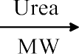



Scheme 13: An overview of the reactions

**Table 3:** Microwave irradiated reactions of various aromatic aldehyde and malononitrile in the presence of urea as a catalyst.

|  |  |  |  |  |  |
| --- | --- | --- | --- | --- | --- |
| **Compound No.** | **Ar** | **Reaction time/Watt** | **Obtained melting point (℃)** | **Literature melting point (℃)** | **Yield (%)** |
| **3a** | 4-CH3C6H4 | 1.5 min/300W | 133-135 | 134 [7] | 89 % |
| **3b** | 4-FC6H4 | 4.5 min/600W | 123-125 | 124-125 [11] | 83 % |
| **3c** | 4-NO2C6H4 | 3.5 min/600W | 161-163 | 160 [12] | 87 % |
| **3d** | 4-ClC6H4 | 4.5 min/800W | 161-163 | 165 [12] | 90 % |

# Conclusion

2-(4-methylbenzylidene) malononitrile, 2-(4-flurobenzylidene)malononitrile, 2-(4- nitrobenzylidene)malononitrile, and 2-(4-chlorobenzylidene)malononitrile, these four substituted olefins were synthesized. The reactions occurred using active methylene compounds such as malononitrile with various substituted aromatic aldehydes in the presence of urea under different microwave irradiation conditions.

Using microwave irradiation, simplified experimental procedures and reduced reaction times with zero carbon emission. This method consistently produces high-purity compounds and a high percentage of yields and usage of easily available and cost-effective urea catalyst which are crucial for industrial applications and align with green chemistry principles. Additionally, microwave synthesis offers cost savings through reduced resource usage and faster production.

This method can also be applied to a broad range of aromatic aldehyde and heterocyclic compounds. All synthesized compounds were purified by recrystallization and characterized by FTIR analysis and further characterization will be done by NMR spectroscopy.

These findings emphasize the social and economic significance of this approach, offering a more efficient and eco-friendly chemical synthesis for the future.

# Reference

1. Freeman F (1981) An efficient synthesis of 2-thienyl methylene malononitrile, Chem. Rev. 80: 329-350
2. Tietze LF (1996), Domino reactions in organic synthesis. Chemical Reviews 96(1): 115-

136. doi: 10.1021/ cr950027e

1. Knoevenagel, E. (1894). Ueber eine Darstellungsweise der Glutarsäure Berichte der deutschen chemischen Gesellschaft, 27, 2345–2346
2. Yang Y, Dong ODW, Pan W, Zhang J and Liu Q (2006), Facile and clean ketene-(S, S)- acetal synthesis of via the aldol 55(2) 2020 α-alkenoyl condensation reactions in water, Tetrahedron 62: 10-111
3. Shanthan Rao, P., & Venkataratnam, R. V. (1991). Zinc chloride as a new catalyst for Knoevenagel condensation. Tetrahedron Letters, 32(41), 5821–5822. doi:10.1016/s0040- 4039(00)93564-0
4. De la, Cruz P, Díez-Barra E, Loupy A and Langa F (1996), Silica gel catalyzed Knoevenagel condensation in dry media under microwave irradiation. Tetrahedron letters 37(7): 1113-1116.
5. Ren, Z., Cao, W., & Tong, W. (2002). The Knoevenagel condensation reaction of aromatic aldehydes with malononitrile by grinding in the absence of solvents and catalysts. Synthetic Communications, 32(22), 3475–3479. doi:10.1081/SCC-120014780
6. Kaupp, G., Reza Naimi-Jamal, M., & Schmeyers, J. (2003). Solvent-free Knoevenagel condensations and Michael additions in the solid state and the melt with quantitative yield. Tetrahedron, 59(21), 3753–3760. doi:10.1016/s0040-4020(03)00554-4
7. BeMiller, J. N., & Huber, K. C. (2015). Physical Modification of Food Starch Functionalities. Annual Review of Food Science and Technology, 6(1), 19–69. doi:10.1146/annual-food-022814-015552
8. Halliday, D.; Resnick, R. and Walker, J (1997). In fundamentals of physics,5th ed. p 570
9. Fan, J., De Bruyn Mario, Budarin, V. L., Gronnow, M. J., Shuttleworth, P. S., Breeden, S. Clark, J. H. (2013). Direct Microwave-Assisted Hydrothermal Depolymerization of Cellulose. Journal of the American Chemical Society, 135(32), 11728–11731. doi:10.1021/ja4056273
10. Sun Qi, Shi, Lan-Xiang S, Ze-Mei G, Tie-Ming C and Run-Tao L (2005), An efficient and green procedure for the Knoevenagel condensation catalyzed by urea, Chinese Journal of Chemistry 23(6): 745-748. doi: 10.1002/cjoc.200590745